# Host a Website on Amazon S3

In this project, we'll use Amazon S3 (which stands for Amazon Simple Storage Service) to host a website.

Create a bucket in Amazon S3

* Open Amazon S3.
* Create a storage space for your website files.
* [**Log in to AWS.**](https://console.aws.amazon.com/console/home?nc2=h_ct&src=header-signin)
* In the AWS Management Console, search for **S3**.

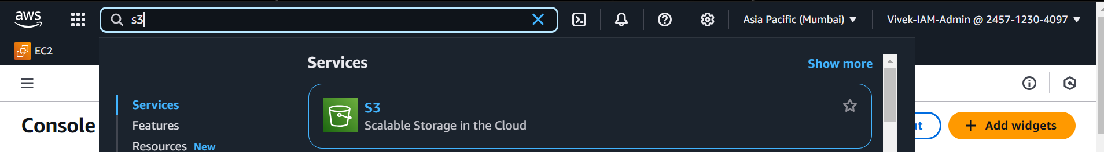

* Select the **AWS Region** closest to you. You can find this at the top right corner of your AWS Management console, right next to your name!
* Choose **Create bucket**.
* For **Bucket name**, enter nextwork-website-project-name
* Make sure to replace name with your name.

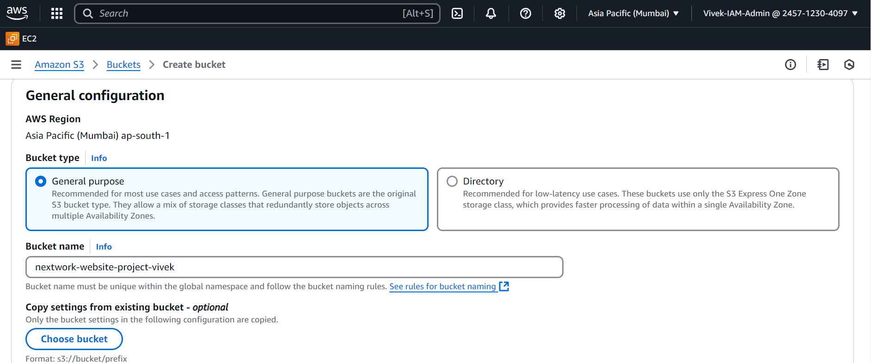

* For **Object Ownership**, choose **ACLs enabled**.

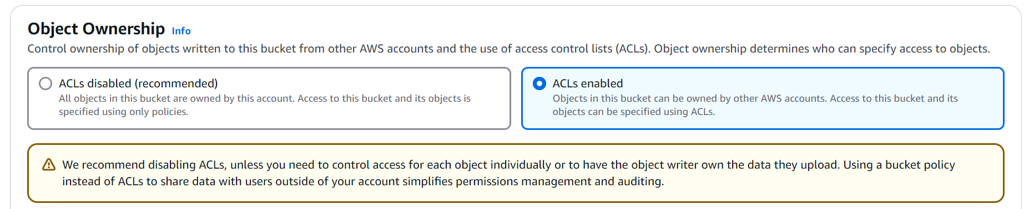

* Choose **Bucket owner preferred**.
* For **Block Public Access settings for this bucket**, clear the check box for **Block all public access**.
* Check the box that says **“I acknowledge that the current settings might result in this bucket and the objects within becoming public.”**

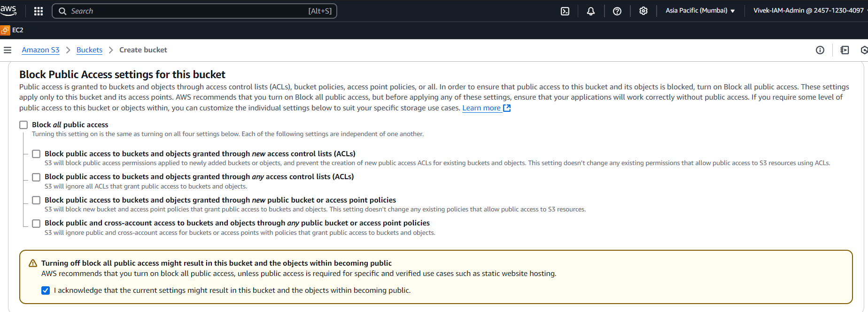

* For **Bucket Versioning**, choose **Enable**.
* Choose **Create bucket**.

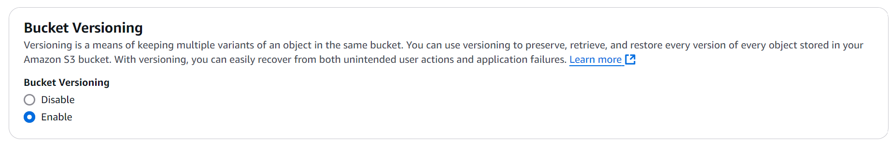

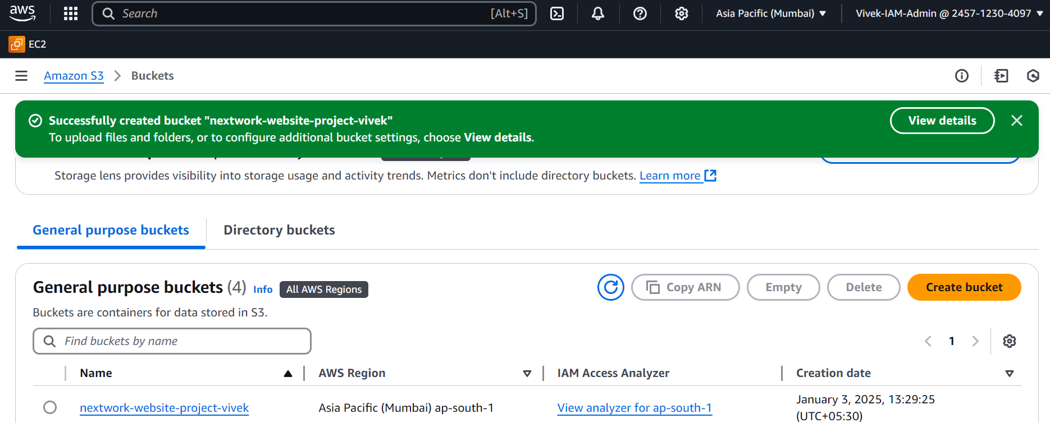

Upload website content to your bucket

your S3 bucket all created.

Time to get those website's files inside your bucket.

**In this step, get ready to:**

* Download an HTML file that sets up your website.
* Download a zip file of images for your website.
* Upload both files into your S3 bucket.

the links for html file and images are as follows:

HTML File: <https://storage.googleapis.com/nextwork_course_resources/courses/aws/AWS%20Project%20People%20projects/Project%3A%20Host%20a%20Static%20Website%20on%20Amazon%20S3/index.html>

Images Zip File:

<https://storage.googleapis.com/nextwork_course_resources/courses/aws/AWS%20Project%20People%20projects/Project%3A%20Host%20a%20Static%20Website%20on%20Amazon%20S3/NextWork%20-%20Everyone%20should%20be%20in%20a%20job%20they%20love_files.zip>

Download these files and save in your local computer before uploading to the bucket

Make sure you unzip the Images Zip File, inside the zip file you will find the folder **“NextWork - Everyone should be in a job they love_files”**

You have to upload that folder along with html file to your S3 Bucket

* In the **Buckets** section, choose the name of your new bucket.
* Upload these files into your bucket
* In Amazon S3 console with your bucket page open. Choose the **Objects** tab.
* Choose **Upload**.

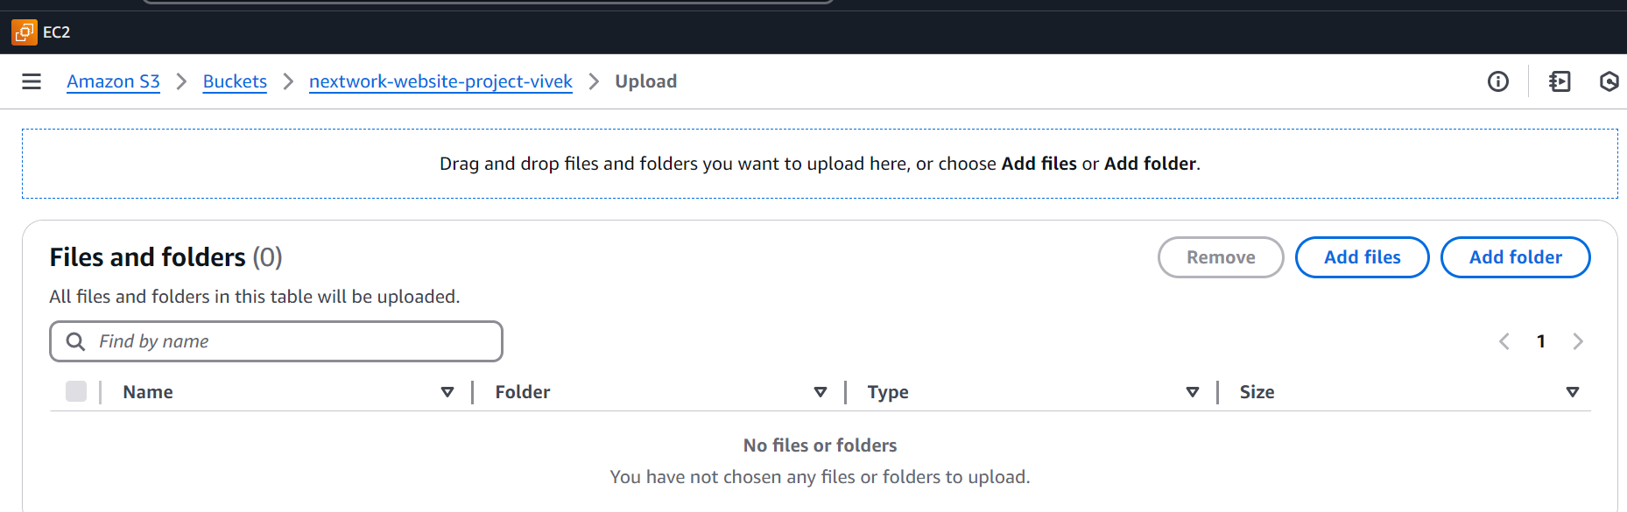

* Choose **Add files**.
* Choose **index.html**.
* Choose **Add folder**.

Choose the unzipped folder **“NextWork - Everyone should be in a job they love_files”** - NOT the zip file itself!

* You might get a popup that tells you that all files in that folder will be uploaded.
* Choose **Upload**.
* S3 will get to work right away!

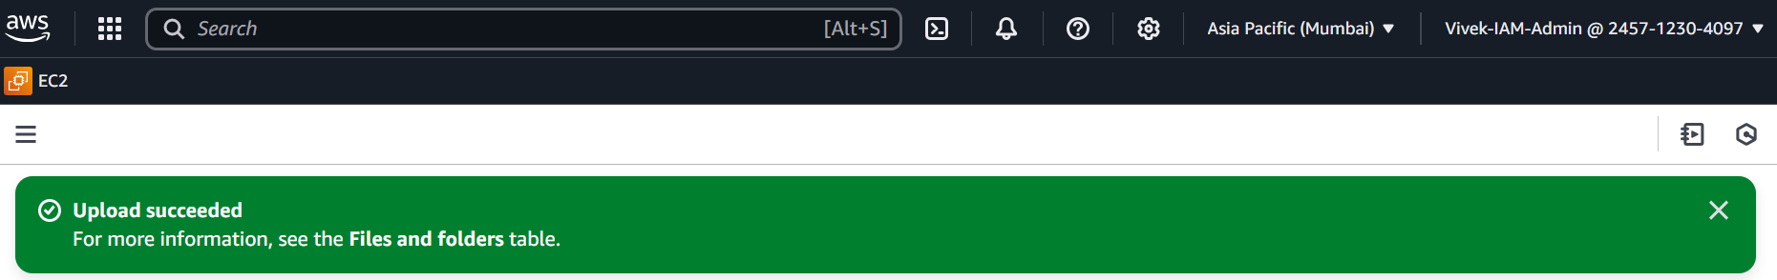

Configure a static website on Amazon S3

S3 bucket? Created.

Website files? Uploaded.

Next up, let's make your website available on the internet by setting up **static website hosting!**

**In this step, get ready to:**

* Configure your S3 bucket for static website hosting
* Visit your public website link.
* Make sure you're back in your bucket's page. If you're not sure, choose **Buckets** on the left-hand side navigation bar, and then choose the bucket you created for this project.
* Choose the **Properties** tab.
* Scroll all the way down to the **Static website hosting** panel.
* Choose **Edit**.
* Configure the following settings:
  + **Static web hosting:** Choose **Enable**.
  + **Hosting type:** Choose **Host a static website**.
  + **Index document:** Enter index.html

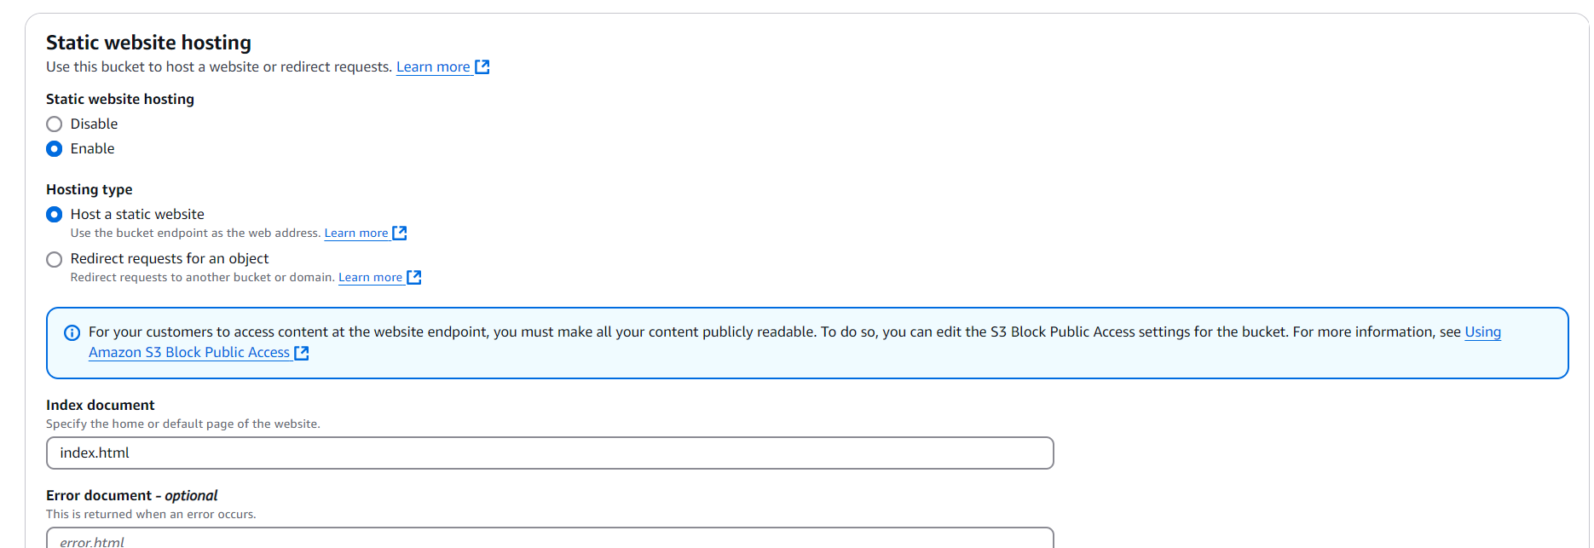

* Choose **Save changes**.
* In the **Static website hosting** panel, click on the URL under **Bucket website endpoint**.

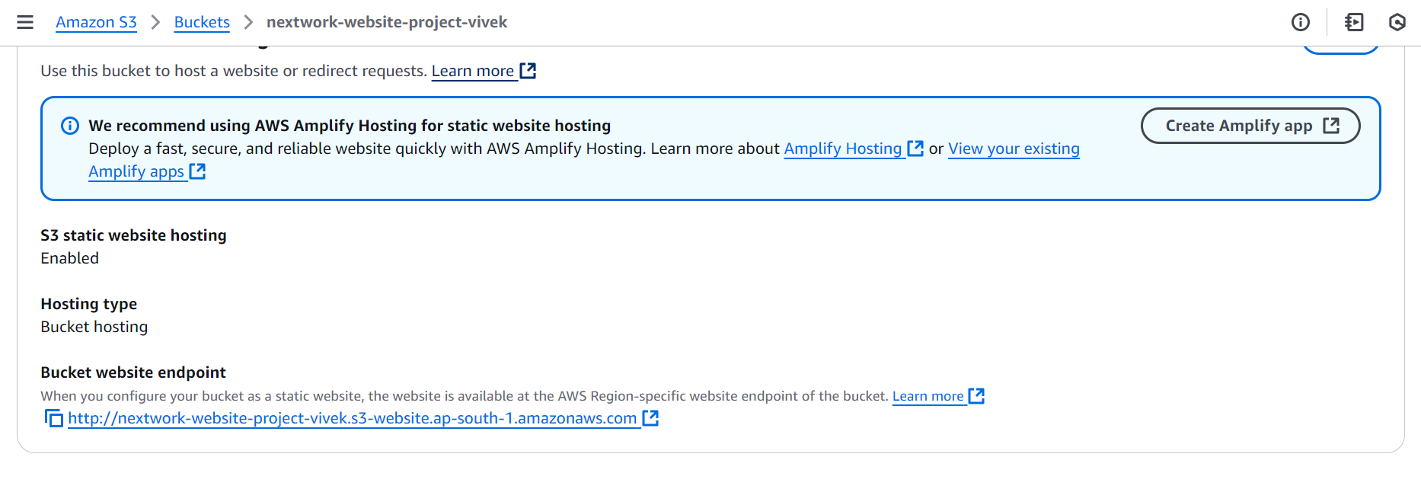

An error! While accessing that URL

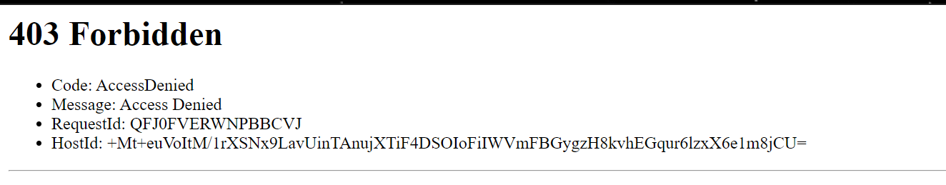

**Why did I get this error?**  
Objects (in this case, the HTML and images files you uploaded) are private by default. This default setting helps keep your account's data secure.

The error message you're seeing is telling you that your static website is being hosted by S3, but the actual HTML/image files you've uploaded are still private. It's kind of like having a bucket on display, so everyone can see the bucket - but the contents are covered up, preventing anyone from seeing what's inside.

To solve this error, we need to set the permission of the objects to public - this is why we enabled ACLs

Make objects in your S3 bucket public

The only missing ingredient is to make your website files **publicly accessible,** so everyone has permission to view your website.

**In this step, get ready to:**

* Make your website files in S3 publicly accessible.
* See your website live on the internet!
* Keep the error message tab open and switch back to the Amazon S3 console tab.
* Would you still remember how to view your S3 bucket's objects? Try finding your bucket's **Objects** page and making your objects public using ACLs.
* Head to the **Objects** tab.
* Select the checkboxes next to your **index.html** file and the folder of website assets.
* In the **Actions** dropdown, choose **Make public using ACL**.

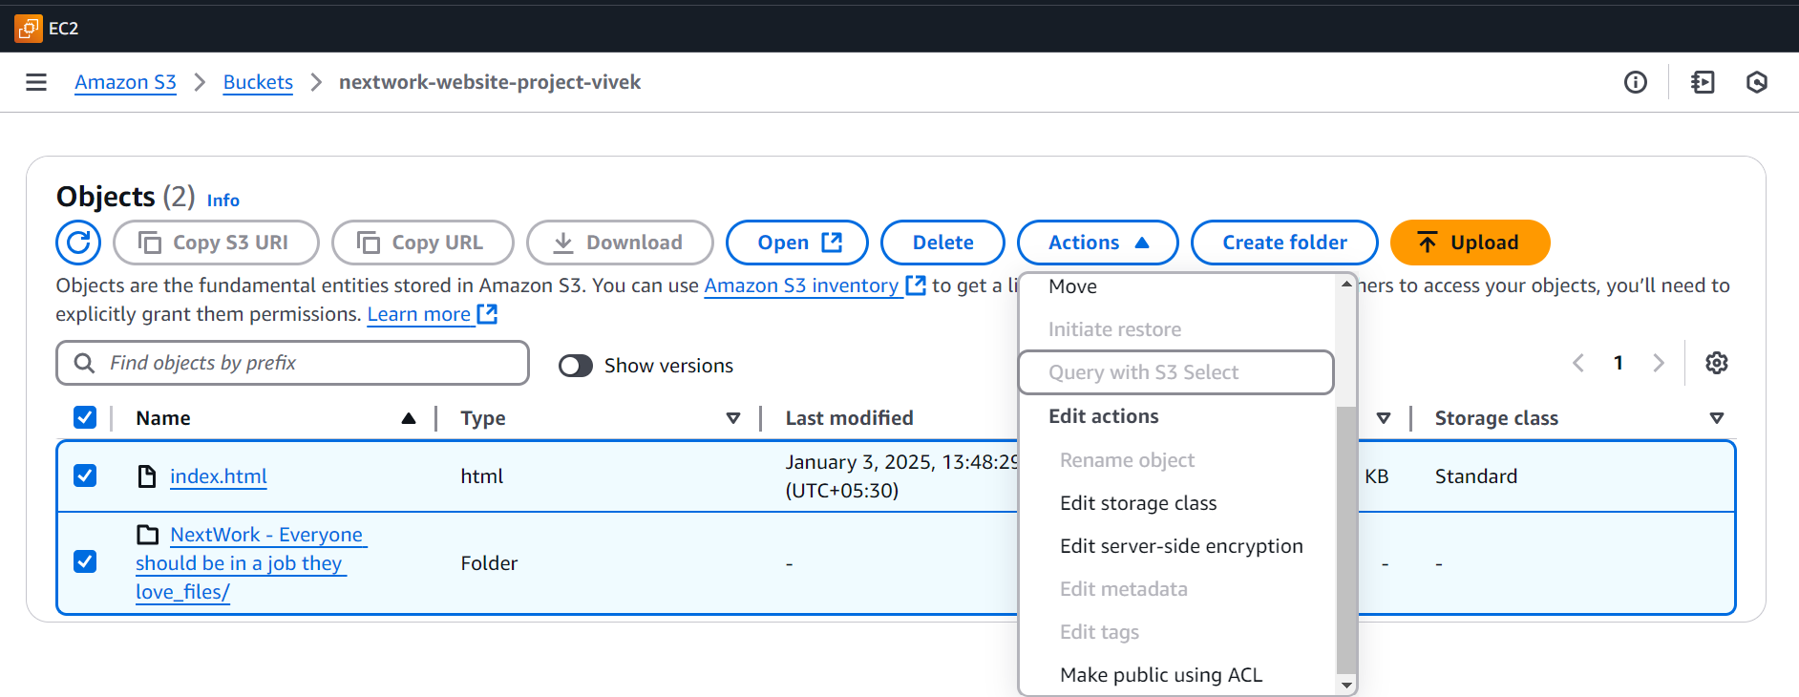

* Choose **Make public.**
* Once the green banner pops up, choose **Close**.

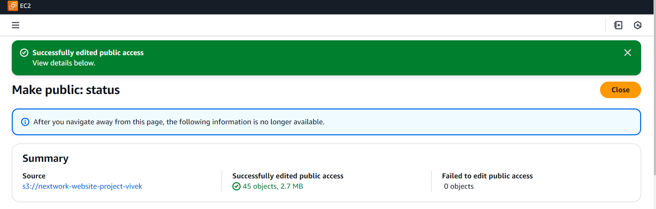

* Return to the web browser tab that has the **403 Forbidden** message.
* Refresh the tab.

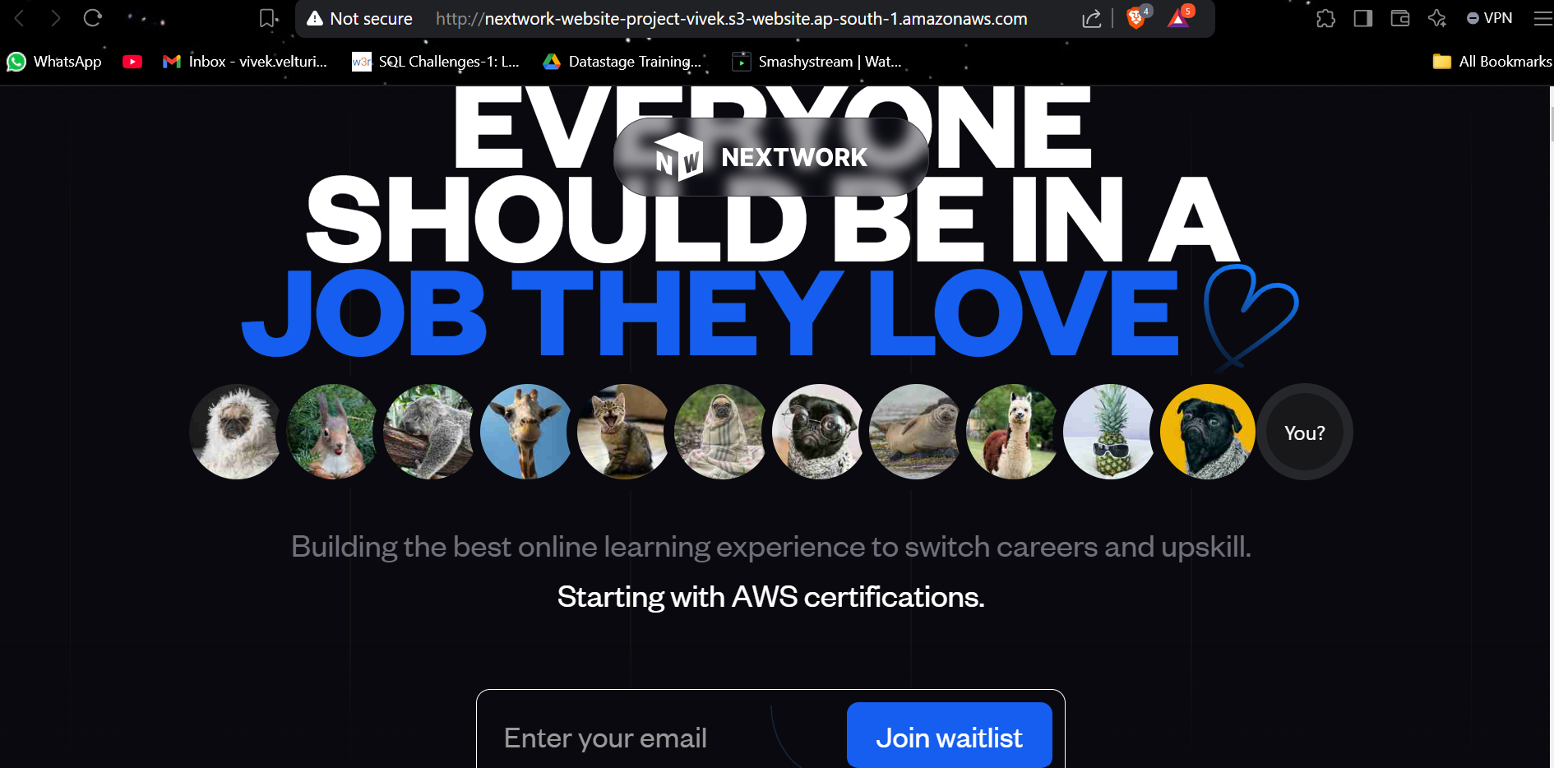

**We have successfully hosted your very own static website on Amazon S3.**